**GOVERNMENT POLYTECHNIC RATNAGIRI**



A Project Report on

**FITNESS SYSTEM WEBSITE**

Submitted to

**COMPUTER ENGINEERING DEPARTMENT**

Under the guidance of

**A.A.KARKARE**

Submitted by

1. SOHAM PRABHAKAR KHANVILKAR (3203)

2. TEJAS DILIP RASAL (3204)

3. ADITI SANJAY KADAM (3224)

Through

**GOVERNMENT POLYTECHNIC RATNAGIRI.**

**2021-22**



**MAHARASHTRA STATE BOARD OF**

**TECHNICAL EDUCATION**

**Certificate**

This is to certify that **Soham Khanvilkar, Tejas Rasal, Aditi**

**Kadam** from **Government Polytechnic Ratnagiri** (Code:0013) having Enrollment No. **1800130093, 1800130095, 1900130118** has

completed the **Report on Semester V Project Report** having title **“FITNESS SYSTEM WEBSITE”** in the group consisting of **3** candidates under the guidance of faculty Guide.

## G.D.PATNE A.A.KARKARE

**Guide HOD**

**Acknowledgements:**

We feel privileged to express our deepest sense of gratitude and sincere thanks to our project guide Prof. A.A.KARKARE for her excellence guidance throughout our project work. Her prompt and kind help led to the completion of the dissertation work.

We would like to thank our H.O.D (Computer Department) Prof. A.Karkare for giving us the opportunity and the necessary facilities to present this report and providing us with various opportunities to learn. However, it would not have been possible without the kind support and help of many individuals and internet service. We would like to extend our sincere thanks to all of them.

Last but not the least we would like to thank the college staff for providing us facilities and source that we needed for this project.

# Abstract:

# Today's demanding lifestyle people need to be healthy for tension free life and also physical fitness includes diet, exercise and sleep which have their own importance in each individual's life and everyone should be sensible with regard to these for a healthy life. For human being health is a most important thing and being healthy is first thing that we keep in our mind. Being healthy and fit gives us power to do anything, anywhere.

So we develop a system “Fitness Studio” for a gymnasium in which customer can get all information about the gymnasium and he can access or enroll at the gym via online to access their workout or trainer and diet or consultancy at the best time and place for their schedule. System will provide text chat for user interaction with trainer or consultancy. After certain time, system will work smartly by automatically recommending user for workout and diet by enquiring his profile. Each time when user login to system he have to end by giving feedback as it will help gym management team to update his system if needed.

# CONTENT PAGE

|  |  |  |
| --- | --- | --- |
| **Sr.No** | **Content** | **Page No.** |
| **1.** | **Chapter-1: Introduction** | **6-7** |
| **2.** | **Chapter 2-: Literature Survey** | **8-10** |
| **3.** | **Chapter-3: Scope of project** | **11-12** |
| **4.** | **Chapter-4: Methodology** | **13-15** |
| **5.** | **Chapter-5: Details of design, working.** | **16-22** |
| **6.** | **Chapter-6: Code** | **23-52** |
| **7.** | **Chapter-7: Results and Application** | **53-58** |
| **8.** | **Chapter-8: Conclusion and future scope** | **59-60** |
| **9.** | **Chapter-9: References and Bibliography** | **61-62** |

**Chapter-1 Introduction**

* **Introduction:**

All we know that the human body is the best picture of the human soul. Fitness is essential for healthy and tension free life. It being healthy and fit gives us energy to do anything. And we like to develop such a website for Fitness System which includes perfect diet, exercises, E-commerce platform, etc.

Now provide more support around improving our wellness by allowing us to track health and fitness achievements from anywhere. Additionally, we offer guidance on how to perform specific workouts and provide training regimes that can anyone follow from a the website.

Nowdays everyone need healthy and fit lifestyle. But because of this pandemic not possible for everyone to go gym and join so that’s why our website helps people to take perfect training, diet plan from home for healthy life.

This project is designed to facilitate a fitness system to automates its operations of keeping records and proper database security. The website store data about members, diet, employees, etc. It also provide chat application facility to communicate with trainer for doubt solving.

# Chapter 2- Literature Survey

* **Literature Review:**

**Research Paper 1:**

## Author Name:

1. Kuruhuri Likith Sai.

## 2. Kunduru Gopi Reddy

## 3. Thaniparthi VijayKumar Reddy

* + **Publications:**

International Research Journal of Engineering and Technology (IRJET)

e-ISSN: 2395-0056

p-ISSN: 2395-0072

Volume: 08 Issue: 04 | Apr 2021

## Title of Research Paper:

Online Management System for Gymnasium

## Summary of Paper:

Nowadays every person willing to do gym in online so this website helps them the most. In this pandemic situation some people unable to go outside because of lockdown so using this platform users can get benefits and it was secure and safe compared to outside situations. The shopping portal also useful for those who need to buy an equipment and those items are available at cheap rates so everyone can afford them easily. No paperwork need and do not remember all the payments and person, this all can do by the system using a database and the gymnasium management is performed very well to satisfy all the required things we want in gym.

In the gym outside mainly require proper equipment, maintenance and variability in structure and no need lots of crowding these all user need but when it comes to online user will only prefer particularly and maintain the durability and here prime concern for users is security so online gym will not reveal his data and requirements provide very well to users. The payment can be modified according to different rules and guidelines by admin as required and admin may also inform users about the changes in rules by putting up notifications in the system. Hence the system saves time, effort, and cost.

# Research Paper 2:

## Author Name:

## 1. Manjiri R. Girnale

## G.H.R.C.E.M,Pune

## 2. Sonali S. Jathar

## G.H.R.C.E.M,Pune)

## 3. Komal D. Untwal

## G.H.R.C.E.M,Pune

* + **Publications:**

International Journal of Engineering Technology Science and Research IJETSR

ISSN 2394 – 3386

Issue 11 November 2017

## Title of Research Paper:

Virtual Gym Management System

## Summary of Paper:

In this paper, authors have recommended website “Virtual Gym Management System”. This system will be successfully designed and developed to fulfill the necessary requirements of user, such as recommending proper diet and exercise to user by well-known consultancy & trainer respectively, video or text chat, schedule, online payment and field level validation will perform efficiently .Even this system includes intelligence i.e. after certain data get store, system will recommend diet and exercise to user rather than any trainer and consultancy which will be benefited for admin as well as for user. Therefore this project will be developed to meet the aspirations indicated in the modern age.

**Chapter-3: Scope of project**

# As the technology and passion of being muscular and healthy is increasing day by day.

# So the need for well-organized, computer based gymnasium system has become need of the society and gymnasium industry.

# This system helps Owner and Admin to maintain large data about users and their daily transaction in gymnasium.

# Also suitable for users for their online profile. Our Fitness Studio is best option for it.

# We developed this program because in corona pandemic there is no one can go to gym and do exercise for that’s why we provide online gym system to everyone.

# And our project can be flexible so that anyone can modify it and use for fitness.

# Chapter-4: Methodology

**Fitness System Website:**

All we know that the human body is the best picture of the human soul. Fitness is essential for healthy and tension free life. It being healthy and fit gives us energy to do anything. And we like to develop such a website for Fitness System which includes perfect diet, exercises, E-commerce platform, etc.

Now provide more support around improving our wellness by allowing us to track health and fitness achievements from anywhere. Additionally, we offer guidance on how to perform specific workouts and provide training regimes that can anyone follow from a the website.

Now day everyone need healthy and fit lifestyle. But because of this pandemic not possible for everyone to go gym and join so that’s why our website helps people to take perfect training, diet plan from home for healthy life.

This project is designed to facilitate a fitness system to automates its operations of keeping records and proper database security. The website store data about members, diet, employees, etc. It also provide chat application facility to communicate with trainer for doubt solving.

**This Design System that will manage:**

* System can store data of users.
* It provides diet, exercises, and information related exercise.

# MODULES:

# A. Admin Module:

# Admin login to the system.

# B. Home Page:

# It shows all modules like classes page, packages page, about us page, etc.

# C. About Us Page:

# It shows information fitness studio.

# D. Schedule Page:

# It provides schedule of fitness studio.

# E. Trainer Page:

# It shows information related trainers.

# F. Gallery Page:

# It shows images of exercises or feedback images.

# G. Classes Page:

# It provide classes like yoga, cardio, etc.

# H. Packages Page:

# It provide plan/packages about fitness studio.

# I. Contact Us Page:

# It provide contact details and we can contact to fitness studio.

# J. User Module:

# User can apply in fitness studio by filling registration form.

**Chapter-5: Details of Designs, Working and Processes**

* **The System is developed based on following languages:**

1. **HTML: as Front End:**

HTML stands for Hyper Text Markup Language. It is used to design web pages using markup language. HTML is the combination of Hypertext and Markup language. Hypertext defines the link between the web pages. Markup language is used to define the text document within tag which defines the structure of web pages. This language is used to annotate (make notes for the computer) text so that a machine can understand it and manipulate text accordingly. Most markup languages (e.g. HTML) are human readable. Language uses tags to define what manipulation has to be done on the text. HTML is a markup language used by the browser to manipulate text, images and other content, in order to display it in the required format. HTML was created by Tim Berners-Lee in 1991.

**2. CSS: as Front End:**

Cascading Style Sheets (CSS) is a style sheet language used for describing the look and formatting of a document written in a markup language. Although most often used to change the style of web pages and user interfaces written in HTML and XHTML, the language can be applied to any kind of XML document, including plain XML, SVG and XUL. Along with HTML and JavaScript, CSS is a cornerstone technology used by most websites to create visually engaging web pages, user interfaces for web applications, and user interfaces for many mobile applications.

## 3. PHP: as Backend Language:

## PHP is one of the back-end languages which is known as the scripting language. When a PHP page is requested, the server parses the PHP code, which in most cases results in dynamically created HTML.

PHP solution can work on various operating systems Windows, Linux, Mac, Unix. This programming language provides compatibility with most servers.  PHP is considered to be easy to learn and PHP works quickly and efficiently on a server-side in most cases also It supports different types of databases. PHP is an open-source framework and can be downloaded for free.

## 4. MYSQL: as Database Language:

The latest version of MySQL is one of the world’s most popular databases. It is open source, reliable, compatible with all major hosting providers, cost-effective, and easy to manage. Many organizations are leveraging the data security and strong transactional support offered by MySQL to secure online transactions and enhance customer interactions. However, enterprises using MySQL are presented with several challenges when their apps experience exponential growth and they need additional scale.

Along with understanding why MySQL is the go-to solution for high-growth environments, it is equally important to understand the challenges that can cripple your business operations.

# Implementation:

We developed a website for a gymnasium in which customer can get all information about the gymnasium and he can access or enroll at the gym via online to access their workout or trainer and diet or consultancy at the best time and place for their schedule. We have developed the system such that, it will store information of all trainee/customer . For these we used HTML, CSS, SQL and PHP. After admin logins into system, and manage or handle users information as well as handle all system . Then trainer also upload workout, diet plan, schedule for trainees.

# Diagram:

# DFD LEVEL 0 DIAGRAM FOR CUSTOMER MODULE:

Customer

Register for join class

Fitness Make Payment

Studio

Purchase diet plan

**DFD LEVEL 1 DIAGRAM FOR ADMIN MODULE:**

Admin

**Login**

View details of customer

Fitness Studio

Manage schedule

Manage classes

Manage trainer

**DFD LEVEL 2 DIAGRAM FOR TARINER MODULE:**

Trainer

Create schedule

Fitness Studio Create diet plan

Upload workout/Exercieses

**USECASE DIAGRAM FOR FITNESS STUDIO**:

**Chapter-6: Code**

**Fitness.html:**

<!DOCTYPE html>

<html lang="en">

<head>

<meta charset="UTF-8">

<meta name="viewport" content="width=device-width, initial-scale=1.0">

<link rel="stylesheet" type="text/css" href="style.css">

<link rel="stylesheet" href="https://cdnjs.cloudflare.com/ajax/libs/font-awesome/4.7.0/css/font-awesome.min.css"

integrity="sha512-SfTiTlX6kk+qitfevl/7LibUOeJWlt9rbyDn92a1DqWOw9vWG2MFoays0sgObmWazO5BQPiFucnnEAjpAB+/Sw=="

crossorigin="anonymous" referrerpolicy="no-referrer" />

<link rel="stylesheet" href="../all.css">

<link rel="stylesheet" href="fonts.css">

<title>Fitness Website</title>

</head>

<body>

<!-----header start-------->

<header>

<nav>

<ul>

<li><a href="#">HOME</a></li>

<li> <a href="#">ABOUT US</a></li>

<li><a href="#">SCHEDULE</a></li>

<li> <a href="#">TRAINER</a></li>

<li><a href="#">GALLERY</a></li>

<!------------Drop Down------------>

<li class="dropdown">

<a href="" class="dropbtn">CLASSES</a>

<div class="dropdown-content">

<a href="#">YOGA</a>

<a href="#">AEROBIC</a>

<a href="#">CARDIO</a>

<a href="#">WORKOUT</a>

</div>

<li><a href="#">PACKAGE</a></li>

<li><a href="#">CONTACT US</a></li>

</ul>

</nav>

<div class="logo">

<a href="#"><h1><span> RATNAGIRI </span> FITNESS STUDIO </h1></a>

</header>

<!------------hearder close------------>

<!-------------home section start--------->

<section id="home">

<p1>It Never Gets Easier</p1>

<h3> - you just get stronger - </h3>

<div class="icons">

<q href="#" class="fab fa-facebook"></q>

<q href="#" class="fab fa-instagram"></q>

<q href="#" class="fab fa-twitter"></q>

</div>

</section>

<!-------------home section start Ends--------->

<!------------------About Us------------------->

<div class="content">

<div class="main">

<h6>ABOUT US..</h6>

<div class="para">

We are here for the guidance of any circumstances appeared towards fitness.

We will help you to develop your body , soul and make you a better person with good personality and healthy routine with proper guidance .

Here , we will provide you several options for development of your physical and mentally by physical activities involved and , as per great visualization and gaining better health and diet plans.

Activities provided by us :-

1) classes and schedule :-

2) personal instructor :-

3) Gallery :- for viewing photos of gym

4) packages :-

</div>

</div>

</div>

<!------------------About Us Ends------------------->

<!---------------Schedule Start--------------------->

<main>

<div class="calender">

<div class="sep-calender">

<h9> WEEKLY-SCHEDULE </h9>

<ul class="day">

<al>SUNDAY</al>

<al>MONDAY</al>

<al>TUESDAY</al>

<al>WEDNESDAY</al>

<al>THURSDAY</al>

<al>FIRDAY</al>

<al>SATURDAY</al>

</ul>

<ul class="types">

<al>REST DAY</al>

<al>CHEST DAY</al>

<al>BACK DAY</al>

<al>FUNCTIONAL</al>

<al>SHOULDER/ABS</al>

<al>BICEPS/TRICEPS</al>

<al>LEGS</al>

</ul>

</div>

</div>

</main>

<!---------------Schedule End----------------------->

<!---------------Trainer Starts--------------------->

<div class="heading">

<p>TRAINER</p></div>

<div class="bg">

<div class="cards">

<div class="image">

<img src="11.jpg">

</div>

<div class="title">

<label>YOGA</label>

</div>

<div class="des">

<p>ANISHA MORE</p><br>

<p>Anisha is professional yoga master.she has completed yoga course from Kerala.

She is certified.</p>

<div class="socialicon">

<a href="https://www.facebook.com/soham.khanvilkar.3">

<i class="fa fa-2x fa-facebook" aria-hidden="true"></i>

</a>

<a href="https://instagram.com/ats_0821?utm_medium=copy_link">

<i class="fa fa-2x fa-instagram" aria-hidden="true"></i>

</a>

<a href="">

<i class="fa fa-2x fa-twitter" aria-hidden="true"></i>

</a>

</div>

</div>

</div>

<!--Cards-->

<div class="cards">

<div class="image">

<img src="8.jpg">

</div>

<div class="title">

<label>AEROBIC</label>

</div>

<div class="des">

<p>SOHAM KHANVILKAR</p><br>

<p>Soham khanvilkar is personal trainer of aerobics. He is also certified in aerobic from Aasam.</p>

<div class="socialicon">

<a href="https://www.facebook.com/soham.khanvilkar.3">

<i class="fa fa-2x fa-facebook" aria-hidden="true"></i>

</a>

<a href="https://instagram.com/ats_0821?utm_medium=copy_link">

<i class="fa fa-2x fa-instagram" aria-hidden="true"></i>

</a>

<a href="">

<i class="fa fa-2x fa-twitter" aria-hidden="true"></i>

</a>

</div>

</div>

</div>

<!--Cards-->

<div class="cards">

<div class="image">

<img src="12.jpg">

</div>

<div class="title">

<label>CARDIO</label>

</div>

<div class="des">

<p>MANTHAN BANE</p><br>

<p>Manthan bane is professional cardio trainer.He is an indiviual plus group trainer.

He is achieve gym/cardio certification.</p>

<div class="socialicon">

<a href="https://www.facebook.com/soham.khanvilkar.3">

<i class="fa fa-2x fa-facebook" aria-hidden="true"></i>

</a>

<a href="https://instagram.com/ats_0821?utm_medium=copy_link">

<i class="fa fa-2x fa-instagram" aria-hidden="true"></i>

</a>

<a href="">

<i class="fa fa-2x fa-twitter" aria-hidden="true"></i>

</a>

</div>

</div>

</div>

<div class="main">

<div class="cards">

<div class="image">

<img src="13.jpg">

</div>

<div class="title">

<label>WORKOUT</label>

</div>

<div class="des">

<p>ANIKET PUSALKAR</p><br>

<p>Aniket pusalkar is professional workout trainer.He is an indiviual plus group trainer.

He is achieve gym/cardio/aerobics certification.</p>

<div class="socialicon">

<a href="https://www.facebook.com/soham.khanvilkar.3">

<i class="fa fa-2x fa-facebook" aria-hidden="true"></i>

</a>

<a href="https://instagram.com/ats_0821?utm_medium=copy_link">

<i class="fa fa-2x fa-instagram" aria-hidden="true"></i>

</a>

<a href="">

<i class="fa fa-2x fa-twitter" aria-hidden="true"></i>

</a>

</div>

</div>

</div>

</div>

</div>

</div>

<!---------------Trainer Starts Ends--------------------->

<!------Gallery Starts--------->

<div class="bg1">

<div class="gall">

<div class="heading1">

<label1>GALLERY</label1>

</div>

<div class="box">

<div class="dream">

<img src="1.jpg">

<img src="3.jpg">

<img src="7.jpg">

<img src="14.jpeg">

<img src="24.jpg">

<img src="18.jpg">

</div>

<div class="dream">

<img src="22.png">

<img src="23.jpg">

<img src="22jpg.jpg">

<img src="24.jpg">

<img src="25.jpg">

<img src="26.jpg">

</div>

<div class="dream">

<img src="27.jpg">

<img src="28.jpg">

<img src="32.jpg">

<img src="31.jpg">

<img src="33.jpg">

<img src="34.jpg">

</div>

</div>

</div>

</div>

<!------Gallery Starts End----->

<!--classes section------->

<div class="classe1">

<div class="title">

<p>OUR CLASSES</p>

</div>

<div class="box">

<div class="box1">

<img src="36.jpg">

<a href="yoga.html">

<button class="btn1">YOGA</button>

</a>

</div>

<div class="box2">

<img src="37.jpg">

<a href="aerobic.html">

<button class="btn2">AEROBIC</button>

</a>

</div>

<div class="box3">

<img src="35.jpg">

<a href="cardio.html">

<button class="btn3">CARDIO</button>

</a>

</div>

<div class="box4">

<img src="39.jpg">

<a href="workout.html">

<button class="btn4">WORKOUT</button>

</a>

</div>

</div>

</div>

</div>

</div>

</div>

<!------Class end----------->

<!------packages------->

<div class="container">

<h1>Membership Plan</h1>

<div class="plan-name">

<div class="price-col">

<p>1 Month</p>

<h2>800Rs</h2>

<div class="cm">

<ul>

<li>Yoga</li>

<li>Aerobic</li>

<li>Cardio</li>

<li>Workout</li>

<a href="REGISTRATION.html"><button>Check-Out</button></a>

</ul>

</div>

</div>

<div class="price-col">

<p>3 Month</p>

<h2>2000Rs</h2>

<div class="cm">

<ul>

<li>Yoga</li>

<li>Aerobic</li>

<li>Cardio</li>

<li>Workout</li>

<button>Check-Out</button>

</ul>

</div>

</div>

<div class="price-col">

<p>6 Month</p>

<h2>3500Rs</h2>

<div class="cm">

<ul>

<li>Yoga</li>

<li>Aerobic</li>

<li>Cardio</li>

<li>Workout</li>

<button>Check-Out</button>

</ul>

</div>

</div>

</div>

</div>

<!------packages End------->

<!---------ContactUS----------->

<section class="TT">

<div class="social-icon">

<a href="https://www.facebook.com/soham.khanvilkar.3">

<i class="fa fa-2x fa-facebook" aria-hidden="true"></i>

</a>

<a href="https://instagram.com/ats_0821?utm_medium=copy_link">

<i class="fa fa-2x fa-instagram" aria-hidden="true"></i>

</a>

<a href="">

<i class="fa fa-2x fa-twitter" aria-hidden="true"></i>

</a>

</div>

<div class="contsctFrom">

<form class="cont_form">

<h3>Send Message</h3>

<div class="inputBox">

<input class="name" type="text" placeholder="Name">

</div>

<div class="inputBox">

<input class="email" type="text" placeholder="Email">

</div>

<div class="inputBox">

<textarea class="msg" rows="5" cols="5" placeholder="Your Message"></textarea>

</div>

<div class="inputBox">

<button type="submit">Submit</button>

</form>

</div>

</div>

</section>

<!---------ContactUS End----------->

<section class="footer">

<div class="box-container">

<div class="footer-col">

<h4>About Us</h4>

<p>We are here for the guidance of any circumstances appeared towards fitness.

We will help you to develop your body , soul and make you a better person with good personality and healthy routine with

proper guidance .

Here , we will provide you several options for development of your physical and mentally by physical activities

involved and , as per great visualization and gaining better health and diet plans.

Activities provided by us :-

1) classes and schedule :-

2) personal instructor :-

3) Gallery :- for viewing photos of gym

4) packages :-</p>

</div>

<div class="contactInfo">

<div class="box">

<div class="icon"> <i class="fa fa-map-marker" aria-hidden="true"></i></div>

<div class="text">

<h2>Address</h2>

<p>RFS,Aarogyamandir,Ratnagiri</p>

</div>

</div>

<div class="box">

<div class="icon"><i class="fa fa-phone-square" aria-hidden="true"></i></div>

<div class="text">

<h2>Phone</h2>

<p>9834499487</p>

</div>

</div>

<div class="box">

<div class="icon"> <i class="fa fa-envelope-o" aria-hidden="true"></i></div>

<div class="text">

<h2>Email</h2>

<p>ATS11@gmail.com</p>

</div>

</div>

</div>

<div class="social-icon">

<a href="https://www.facebook.com/soham.khanvilkar.3">

<i class="fa fa-2x fa-facebook" aria-hidden="true"></i>

</a>

<a href="https://instagram.com/ats_0821?utm_medium=copy_link">

<i class="fa fa-2x fa-instagram" aria-hidden="true"></i>

</a>

<a href="">

<i class="fa fa-2x fa-twitter" aria-hidden="true"></i>

</a>

</div>

</div>

</section>

</body>

</html>

**Style.css:**

*{

font-family:'Exo 2', sans-serif;

font-style: italic;

text-transform: uppercase;

transform: all .2s linear;

box-sizing: border-box;

margin: 0; padding: 0;

}

html{

font-size: 62.5%;

scroll-behavior: smooth;

}

body{

overflow-x: hidden;

}

header{

width:100%;

display:flex;

align-items:center;

justify-content: space-between;

position: fixed;

top: 0%; left: 0;

padding: 2rem 3rem;

z-index: 10;

}

ul{

list-style-type: none;

display: flex;

align-items: center;

justify-content: space-between;

}

li{

margin: 1rem 1.5rem;

}

a{

font-size: 1.1rem;

text-decoration: none;

color: #fff;

padding: 1rem;

}

a:hover{

background:rgb(255, 0, 0);

}

.dropbtn{

padding: 15px;

border: 10px;

}

.dropdown{

cursor: pointer;

display: inline-block;

}

.dropdown-content{

display: none;

position: absolute;

min-width: 16px 12px;

}

.dropdown-content a{

color: rgb(243, 232, 232);

text-decoration: none;

display: block;

padding: 12px 16px;

}

.dropdown-content a:hover

{

background-color:rgb(248, 6, 6);

}

.dropdown:hover .dropdown-content{

display:block;

}

.dropdown:hover .dropdown-content{

background-color: rgb(1, 0, 3);

}

.logo {

margin:0 1.5rem;

}

a{

text-decoration: none;

}

h1{

font-size: 2rem;

color: #fff;

}

span{

color:rgba(248, 9, 109, 0.979);

}

#home{

height:100vh;

width:100vw;

display:flex;

align-items:center;

justify-content:center;

flex-flow:column;

background:url(1.jpg), linear-gradient(rgba(0,0,0,.8),rgba(0,0,0,.8));

background-size:cover;

background-position:center;

background-blend-mode: multiply;

background-attachment:fixed;

padding-top:5rem;

position: relative;

text-align:center;

}

p1{

font-size: 5rem;

margin:0 .5rem;

color:#fff;

}

h3{

font-size: 2.5rem;

color:rgb(247, 7, 7);

margin:1rem 0;

}

.icons{

position: absolute;

bottom: 3.5rem; left:5rem;

z-index:1;

}

q{

text-decoration: none;

font-size: 3rem;

margin:0 1rem;

color:#fff;

}

q:hover{

color:rgb(252, 248, 248);

}

.content{

height:100vh;

width:100vw;

background: url("21.jpg")no-repeat;

background-size:cover;

background-position: center;

}

h6{

font-size: 25px;

margin:auto;

color:rgb(255, 4, 4);

text-align:center;

padding: 50px;

position:absolute;

top: 120%;

left: 60%;

transform: translate(-50,-50%);

}

.para{

width:45%;

float:right;

background-color:white;

padding:75px;

margin-right:500px;

margin-top:200px;

font-size:15px;

font-family:Cambria, Cochin, Georgia, Times, 'Times New Roman', serif;

border-radius:5px;

box-shadow:4px 4px 20px rgb(187, 184, 184);

}

.para:hover{

box-shadow:15px 15px 5px;

transition:1s;

color:rgb(0, 0, 0);

}

body{

text-transform:uppercase;

background-color: rgb(247, 243, 247);

}

.h9{

font-size: 30px;

margin:auto;

color:rgb(126, 10, 10);

}

.calender{

height:100vh;

width:100vw;

background: url("5.jpg")no-repeat;

background-size:cover;

background-position: center;

background-attachment:fixed;

padding-top:5rem;

position: relative;

text-align:center;

display: flex;

align-items: center;

justify-content: space-around;

flex-wrap:wrap;

gap:1rem;

font-weight:900;

font-family: 'Times New Roman', Times, serif;

font-size: 15px;

color:rgb(248, 6, 6);

}

.sep-calender ul{

box-shadow:10px 1px 1px 1px rgb(255, 255, 255);

border:20px rgb(255, 254, 254);

padding: 20px;

}

.sep-calender .h9{

text-align:center;

padding:1rem;

}

.sep-calender ul{

display:grid;

grid-template-columns:repeat(7,1fr);

list-style:none;

}

al{

padding:5px;

text-align:center;

color:blanchedalmond;

}

al:nth-child(7n + 1){

color:rgb(240, 21, 21);

}

al:nth-child(7n - 3){

color:rgb(10, 243, 49);

}

/*--------*/

.heading{

font-size:25px;

text-align:center;

color:rgb(255, 0, 0);

padding:30px;

position:absolute;

padding-left:650px;

font-weight:bold;

}

.bg{

background-image:url("45.jpg");

background-repeat:no-repeat;

background-size:cover;

width:100vw;

}

.bg .des{

font-size: 10px;

}

.socialicon a{

border-radius:50px;

text-align:center;

margin:10px;

}

.socialicon{

display:flex;

margin-top:10px;

margin-left:100px;

size:20%;

}

.cards{

width:25%;

display:inline-block;

background-color:rgb(253, 252, 252);

border-radius:5px;

margin:50px;

box-shadow:4px 4px 20px rgb(187, 184, 184);

}

.cards:hover{

box-shadow:4px 4px 20px rgb(12, 12, 12);

}

.image img{

width:100%;

border-radius:5px;

}

.title{

text-align:center;

}

.des{

text-align:center;

padding:5px;

}

button{

height:45px;

width:100px;

font-size:12px;

margin-top:30px;

margin-bottom:30px;

background-color:rgb(255, 255, 255);

border-radius:5px;

}

button:hover{

background-color:rgb(3, 3, 3);

color:rgb(255, 255, 255);

transition:1s;

cursor:pointer;

}

.main{

margin-left:460px;

width:95%;

}

/*--------*/

.gall{

background-color:black;

width:100vw;

display:flex;

flex-direction:column;

justify-content:center;

align-items:center;

text-align:center;

margin:0px 0px 0 px;

color:red;

}

.gall .heading1{

width:20%;

padding:20px;

}

.gall .heading1 label1{

font-size:3em;

font-weight:bolder;

border-bottom:3px solid rgb(180, 32, 32);

}

.gall .box{

display:flex;

flex-direction:row;

justify-content:space-between;

}

.gall .box .dream{

display:flex;

flex-direction:column;

width:32.5%;

}

.gall .box .dream img{

width:100%;

padding:5px;

border-radius:10px;

}

/*----------------*/

.classe1{

height: 100vh;

background-image:url("");

background-size:cover;

background-repeat:no-repeat;

}

.title p{

font-size:20px;

padding-top:30px;

font-family: latin;

color:rgb(255, 0, 0);

text-align:center;

font-weight:bold;

}

.box{

display:flex;

justify-content: space-between;

}

.box1, .box2, .box3, .box4{

background-color:white;

height:300px;

width:300px;

margin-left:30px;

margin-top:20px;

}

.box1 img{

height:400px;

width:300px;

}

.box1 img:hover{

transform: scale();

transition: 1s;

box-shadow: 5px 10px 20px ;

}

.box4{

margin-right: 30px;

box-shadow: 100px;

}

.box2 img{

height:400px;

width:300px;

}

.box2 img:hover{

transform: scale();

transition: 1s;

box-shadow: 5px 10px 20px ;

}

.box3 img{

height:400px;

width:300px;

}

.box3 img:hover{

transform: scale();

transition: 1s;

box-shadow: 5px 10px 20px ;

}

.box4 img{

height:400px;

width:300px;

}

.box4 img:hover{

transform: scale();

transition: 1s;

box-shadow: 5px 10px 20px ;

}

.btn1{

border: 2px solid black;

background: none;

padding: 10px;

margin: 10px;

font-size: 15px;

font-family: montserrat;

transition: 1s;

position: relative;

overflow: hidden;

}

.btn1:hover{

color:rgb(255, 255, 255);

background-color: black;

}

.btn2{

border: 2px solid black;

background: none;

padding: 10px;

margin: 10px;

font-size: 15px;

font-family: montserrat;

transition: 1s;

position: relative;

overflow: hidden;

}

.btn2:hover{

color: white;

background-color: black;

}

.btn3{

border: 2px solid black;

background: none;

padding: 10px;

margin: 10px;

font-size: 15px;

font-family: montserrat;

transition: 1s;

position: relative;

overflow: hidden;

}

.btn3:hover{

color:white;

}

.btn4{

border: 2px solid black;

background: none;

padding: 10px;

margin: 10px;

font-size: 15px;

font-family: montserrat;

transition: 1s;

position: relative;

overflow: hidden;

}

.btn4:hover{

color:white;

background-color:black;

}

.bg1{

background-color:black;

}

/*-------------------*/

.container{

width:100%;

min-height:100vh;

background:rgb(255, 255, 255);

}

.container h1{

font-size:20px;

padding-top:30px;

font-family:latin;

color:rgb(255, 0, 0);

text-align:center;

font-weight:bold;

}

.plan-name{

width:90%;

max-width:1100px;

margin:auto;

display:grid;

grid-template-columns:repeat(auto-fit,minmax(250px,1fr));

grid-gap:25px;

}

.price-col{

background:white;

padding:10% 15%;

border-radius:10px;

color:rgb(0, 0, 0);

text-align:center;

margin:30px;

box-shadow:4px 4px 20px rgb(187, 184, 184);

}

.price-col p{

font-size:30px;

background-color:#ffbb00;

}

.price-col h2{

font-size:20px;

margin:20px 0 40px;

font-weight:500;

}

.price-col:hover{

transform: scale(1.04)

}

.cm ul{

display:table-cell;

padding-left:50px;

font-size:13px;

font-weight:bold;

}

.cm ul button{

border: 2px solid rgb(255, 166, 0);

font-size:10px;

margin-bottom:30px;

border-radius:5px;

color:rgb(0, 0, 0);

background:rgb(255, 255, 255);

width:5vw;

height:5vh;

}

.cm ul button:hover{

color:white;

background-color:rgb(255, 153, 0);

}

/*------------------*/

.TT{

width:100vw;

height:100vh;

position:relative;

padding:50px 100px;

display:flex;

justify-content:center;

align-items:center;

flex-direction:column;

}

.TT .contactInfo{

width:50%;

display:flex;

flex-direction:column;

}

.TT.contactInfo .box{

position:relative;

padding:20px 0;

display:flex;

}

.TT .contactInfo .box .icon{

min-width:60px;

height:60px;

justify-content:center;

align-items:center;

border-radius:50%;

font-size:22px;

}

.TT .contactInfo .box .text{

display:flex;

padding-right:10px;

font-size:15px;

margin-right:auto;

flex-direction:column;

font-weight:300;

}

.TT .contactInfo .box h2{

font-weight:bold;

color:rgb(12, 77, 161);

}

.TT .contactInfo .box p{

font-size:12px;

}

.contsctFrom{

width:40%;

padding:40px;

background:rgb(231, 230, 230);

}

.contsctFrom h3{

font-size:30px;

color:rgb(0, 0, 0);

font-weight:500;

text-align:center;

}

.contsctFrom .inputBox{

position:relative;

width:100%;

margin-top:20px;

}

.contsctFrom .inputBox input,

.contsctFrom .inputBox textarea{

width:100%;

padding:5px 0;

font-size:16px;

margin:10px 0;

border:none;

border-bottom:2px solid #333;

outline:none;

}

.contsctFrom .inputBox [type="submit"]{

width:100px;

background:#00bcd4;

color:#fff;

border:none;

cursor:pointer;

padding:10px;

font-size:18px;

text-align:center;

}

.icons{

margin-left:100px;

}

.info{

color:black;

padding:30px;

font-size:20px;

line-height:3;

}

.info i{

margin-right: 10px;

}

.social-icon{

display:flex;

margin-top:400px;

margin-right:200px;

size:20%;

}

a i{

color:black;

}

a:hover i{

transform:scale(1.4);

}

.social-icon a{

border-radius:50px;

text-align:center;

margin:10px;

}

/*---footer----*/

.footer .box-container {

display: flex;

flex-wrap: wrap;

gap: 1.5rem;

}

.footer-col h4{

font-size: 18px;

color:#24262b;

text-transform: capitalize;

margin-bottom: 35px;

font-weight: 500;

position: relative;

margin-left:30px;

}

.footer-col h4::before{

content: '';

position: absolute;

left:0;

bottom: -10px;

background-color: #e91e63;

height: 2px;

box-sizing: border-box;

width: 50px;

}

.footer-col p{

width:50px;

text-align: justify;

font-family: 'Times New Roman', Times, serif;

word-spacing: 2px;

font-size:15px;

}

.footer .box-container .box {

flex: 1 1 25rem;

}

.footer .box-container .box h3 {

color: #333;

font-size: 2.5rem;

padding: 1rem 0;

}

.footer .box-container .box a {

display: block;

color: #666;

font-size: 1.5rem;

padding: 1rem 0;

}

.footer .box-container .box a:hover {

color: var(--pink);

text-decoration: underline;

}

.footer .box-container .box img {

margin-top: 1rem;

}

.footer .credit {

text-align: center;

padding: 1.5rem;

margin-top: 1.5rem;

padding-top: 2.5rem;

font-size: 2rem;

color: #333;

border-top: .1rem solid rgba(0, 0, 0, .1);

padding-bottom: 9rem;

}

.footer .credit span {

color: var(--pink);

}

/* media queries */

@media (max-width:991px) {

html {

font-size: 55%;

}

header {

padding: 2rem;

}

section {

padding: 2rem;

}

.home {

background-position: left;

}

}

@media (max-width:768px) {

header .fa-bars {

display: block;

}

header .navbar {

position: absolute;

top: 100%;

left: 0;

right: 0;

background: #eee;

border-top: .1rem solid rgba(0, 0, 0, .1);

clip-path: polygon(0 0, 100% 0, 100% 0, 0 0);

}

header #toggler:checked~.navbar {

clip-path: polygon(0 0, 100% 0, 100% 100%, 0% 100%);

}

header .navbar a {

margin: 1.5rem;

padding: 1.5rem;

background: #fff;

border: .1rem solid rgba(0, 0, 0, .1);

display: block;

}

.home .content h3 {

font-size: 5rem;

}

.home .content span {

font-size: 2.5rem;

}

.icons-container .icons h3 {

font-size: 2rem;

}

.icons-container .icons span {

font-size: 1.7rem;

}

}

@media (max-width:450px) {

html {

font-size: 50%;

}

.heading {

font-size: 3rem;

}

**Chapter-8: Result and Application**

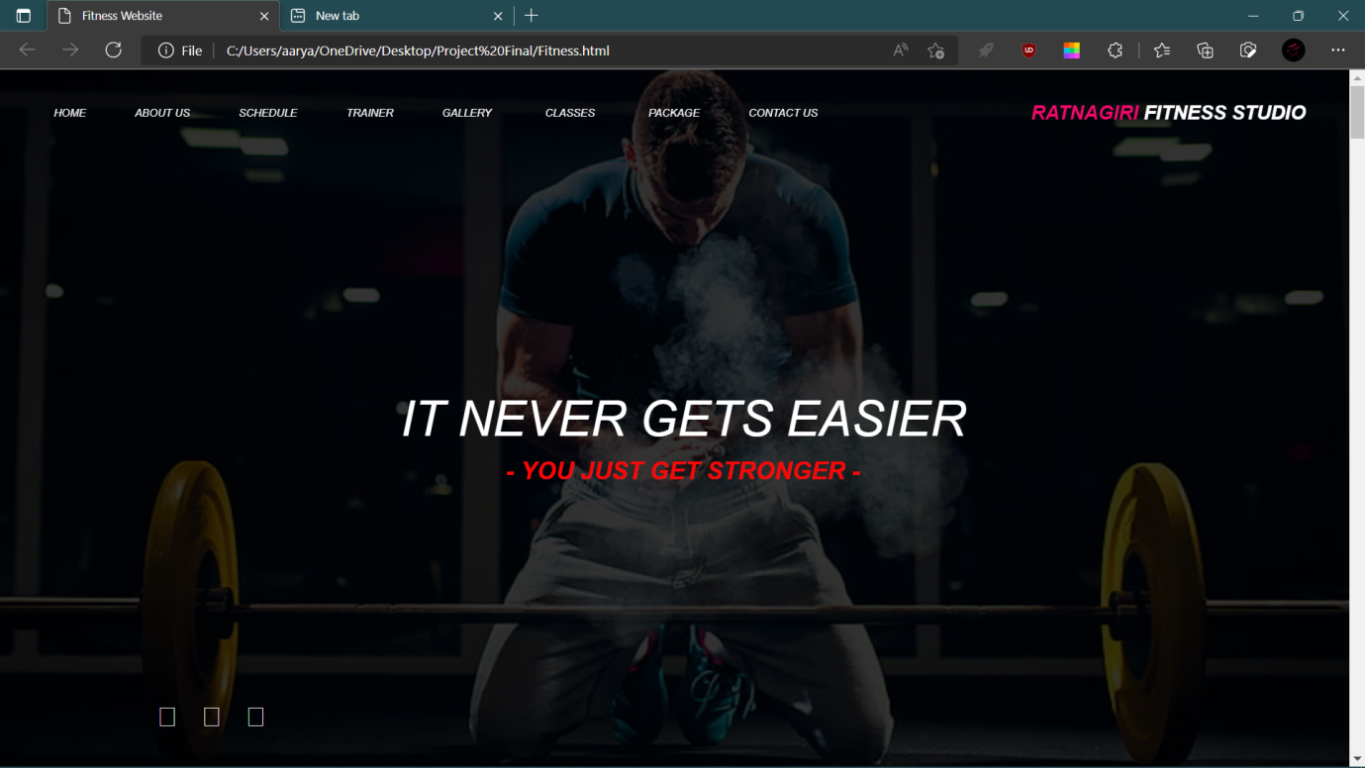

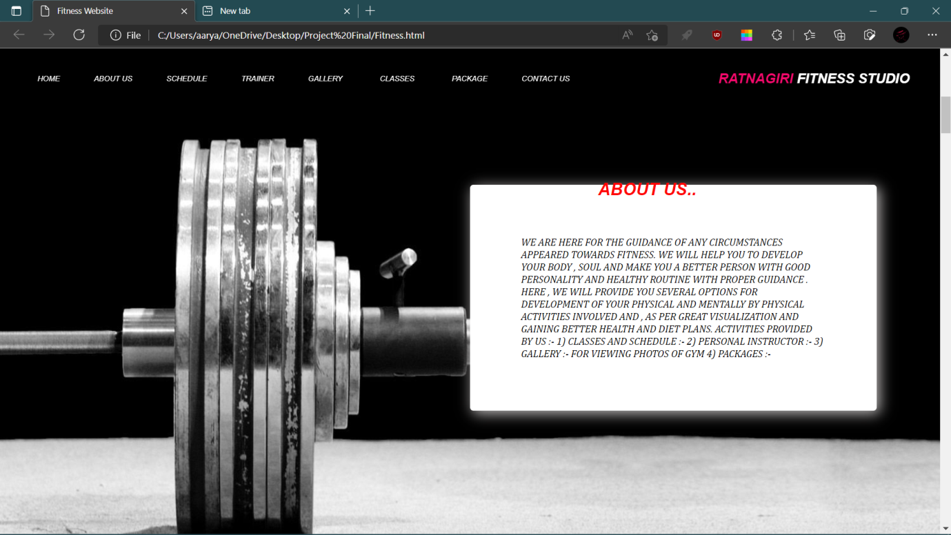

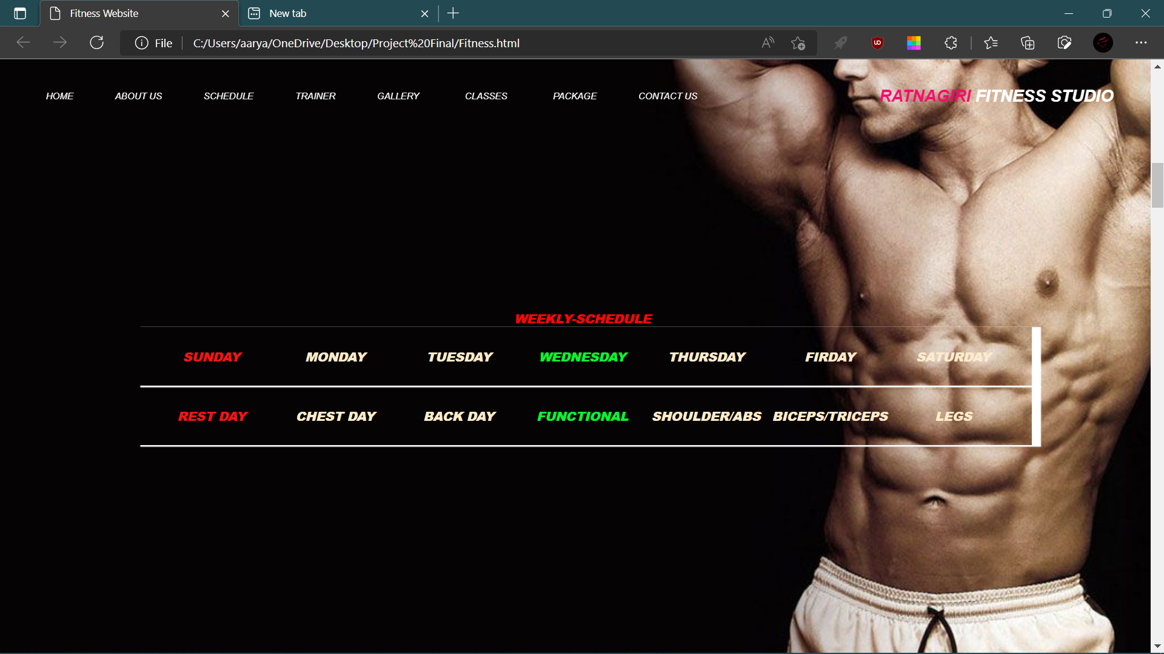

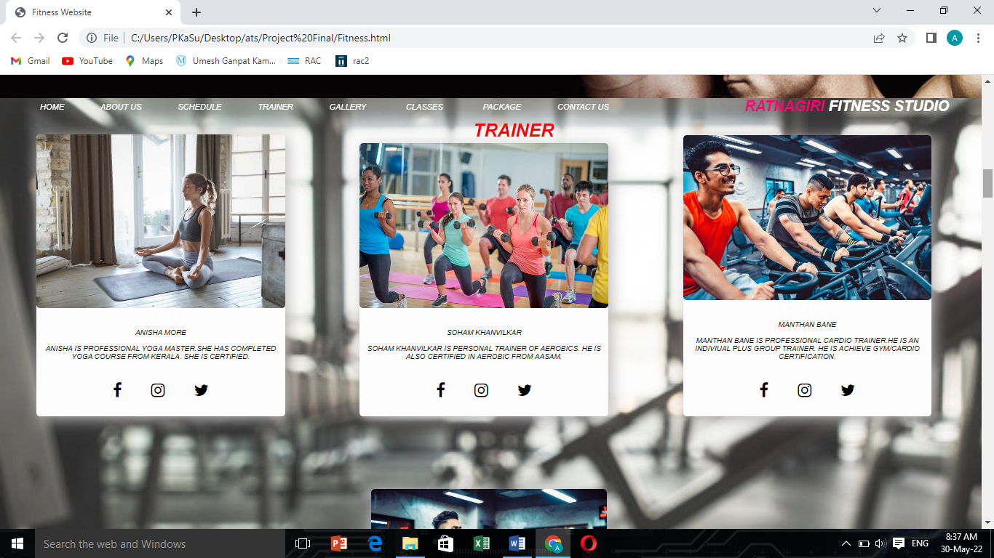

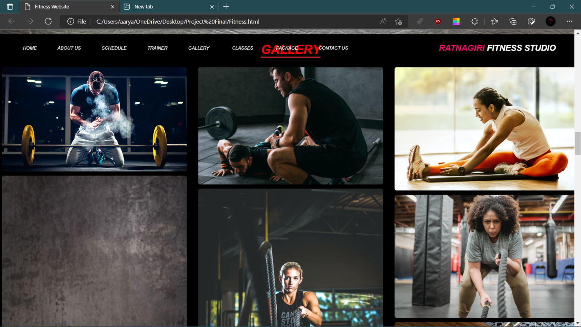

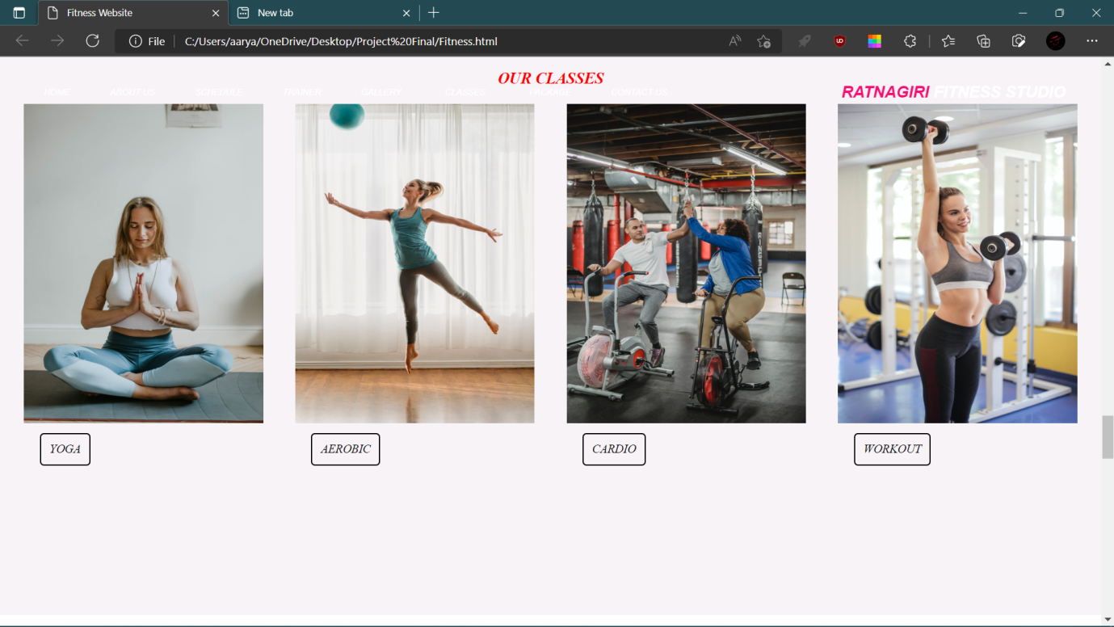

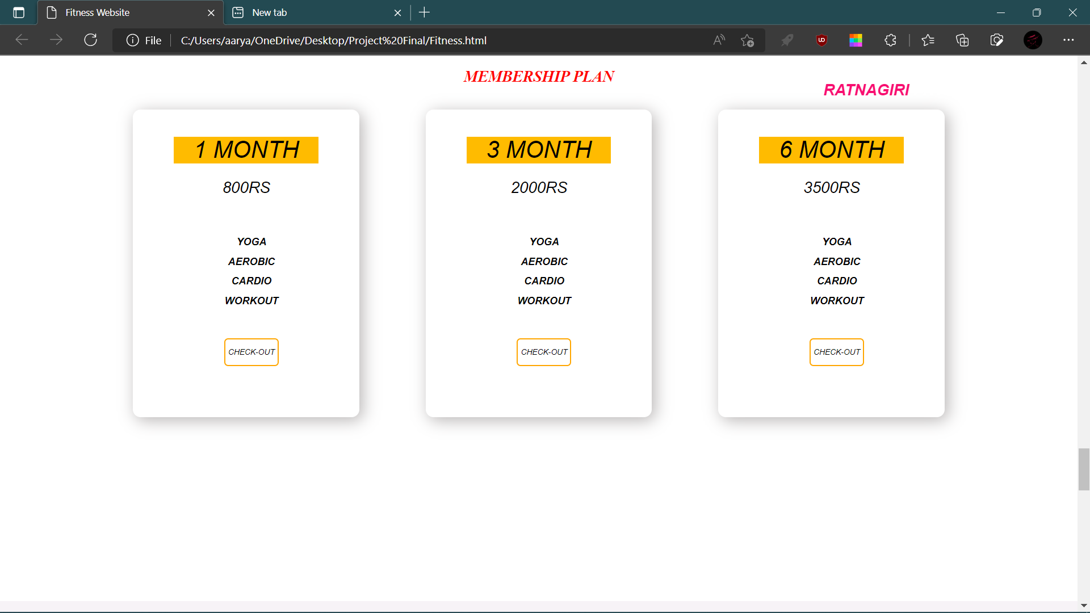

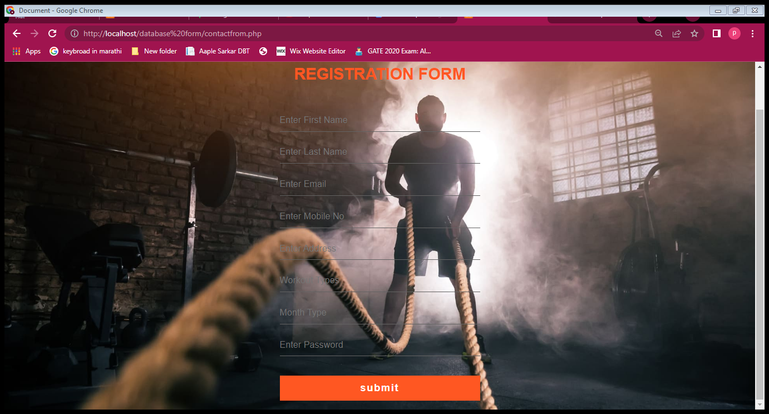

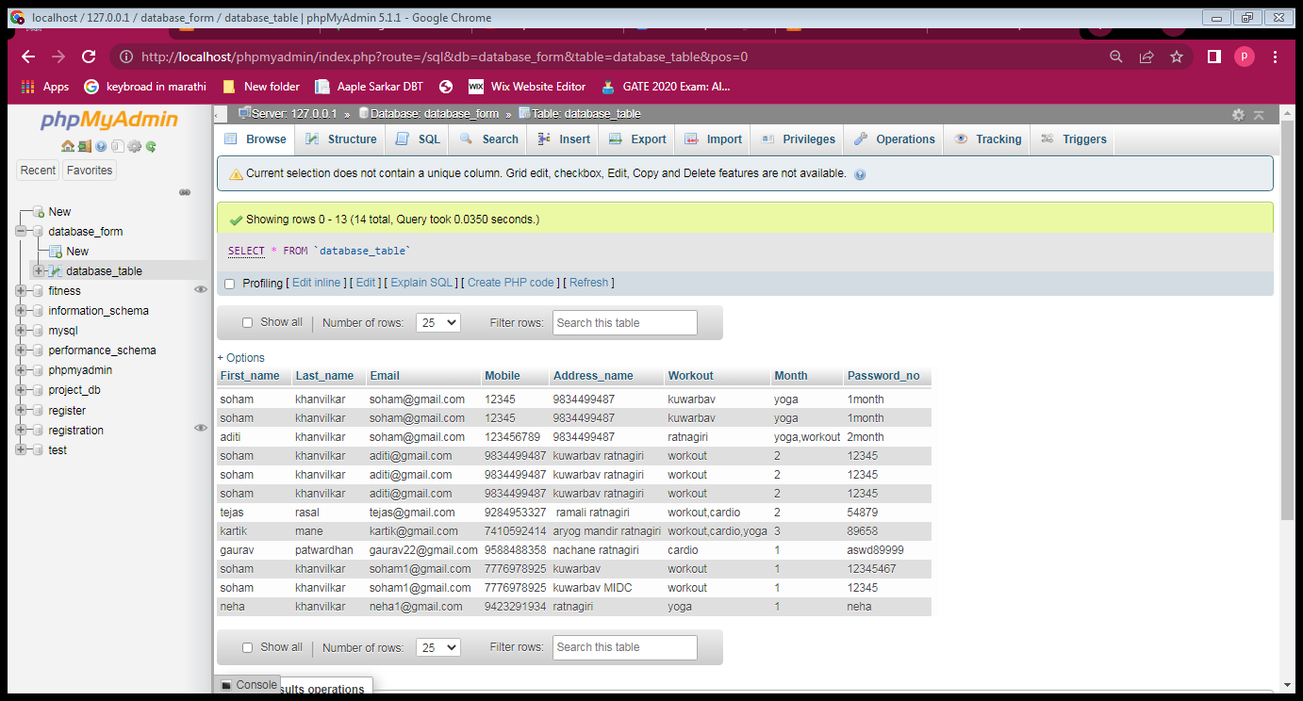

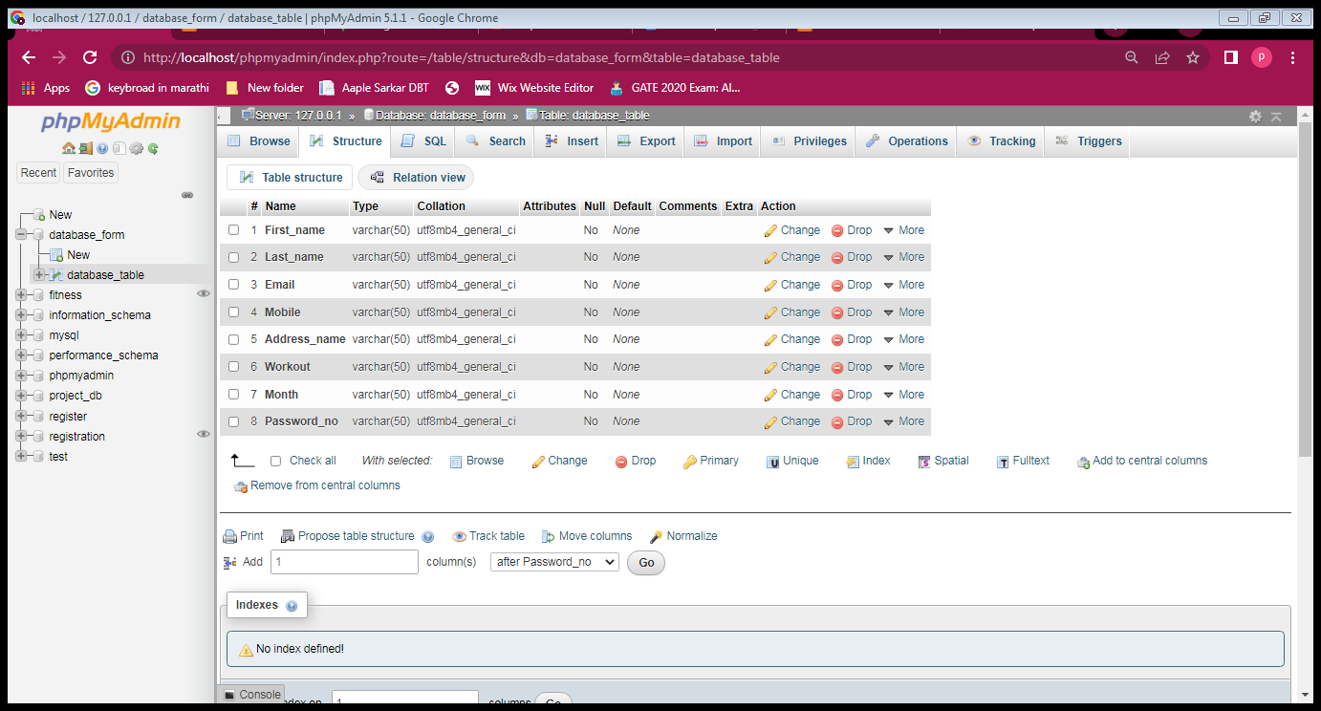

**Chapter-8: Conclusion and Future Scope**

# Conclusion:

The goal of the system is achieved and difficulties are solved. The project is built such that it is user friendly. The fitness management system is properly performed to satisfy all the important requirements that we want in gym. The older system was tackled with so many problems/issues. The present project has been developed to make work easy and efficient. This system is automated system i.e. only use of machine work. The project can be easily used in gym studios.

# Future Scope:

# 

The project has been developed in a very short period of time and all efforts have been taken so that this project is very efficient in its execution there still exists some scope of improvement in our project. The following lists some of the enhancement that can be added incorporate into the project. Application of the project can be done more attractively. Database management and all maintenance module can be updated which helps the administrator. More security measures can be taken. There are also few features which can be integrated with this system to make it more flexible. Below list shows the future points to be consider:

* Real-time Chat BOT option for members and trainer, so that members can directly enquiry theirs trainer on any time through the Chat BOT.
* Automated Fitness suggestion by enquiring the condition of the health.
* Real time Claim Processing Bot.
* Video conversation option for trainers and members.
* Online payment through face recognition
* Barcode generation for membership card and using this, members can take entry to Gym.
* Finger print matching for taking entry to gym

**Chapter-9: References**

# References and Bibliography:

1. Brindal, E., Freyne, J., Saunders, I., Berkovsky, S., Smith, G & Noakes, M. (2012). Features predicting weight loss in overweight or obese participants in a web-based intervention: randomized trial. Journal of Medical Internet Research, 14(6), e173. doi: 10.2196/jmir.2156

2. Hannah E Payne , Cameron Lister, Joshua H West, Jay M Bernhardt (2015) Review, Behavioral functionality of mobile apps in health interventions: a systematic review of the literature JMIR Mhealth Uhealth, 26;3(1):e20., doi: 10.2196/mhealth.3335.

3. Mary Gowin, Marshall Cheney, Shannon Gwin and Taylor Franklin Wann (2015) Health and Fitness App Use in College Students: A Qualitative Study, American Journal of Health Education,46(4):223-230DOI: 10.1080/19325037.2015.1044140